INET 2005 Assignment 1

**Web Application DevELopment I**

# Prerequisites

### Recommended: Labs 1 & 2: PHP Debugging in PhpStorm and PHP Basics.

### Strongly Recommended: Lab 3: Introduction to PHP + MySQL, JavaScript.

# Summary

You will create a web site in PHP that will allow for the viewing, searching, inserting, updating, and deleting of Employee records from the MySQL Employees sample database. Forms to allow for insertion and update will have client-side validation of valid input. Only authorized users will be able to access the system. Some significant value-added innovation will be included on top of the system requirements. The code will be integrated with source control throughout the development process.

# General Requirements

1. **Display of Employee Records (3 pts.)**

Employee records will be displayed in an HTML table with borders and gridlines as seen in Figure 1 below. All fields from the Employees table will be displayed.

1. **Paging through Employee Records (3 pts.)**

Only a maximum of 25 rows from the Employees table will displayed on the page at any one time. The ability to page through the entire record set will be implemented with previous and next buttons/links. This paging feature must not break if users click on the previous link on the first page.

1. **Searching for Employee Records (3 pts.)**

Employee records will be searched for. The user will type a search string in a textbox and only matching results will display. The search string will be preserved in the textbox upon page refresh (i.e. a sticky form). The search string will be matched against both the employee’s last name and first name. See Figure 1 below:

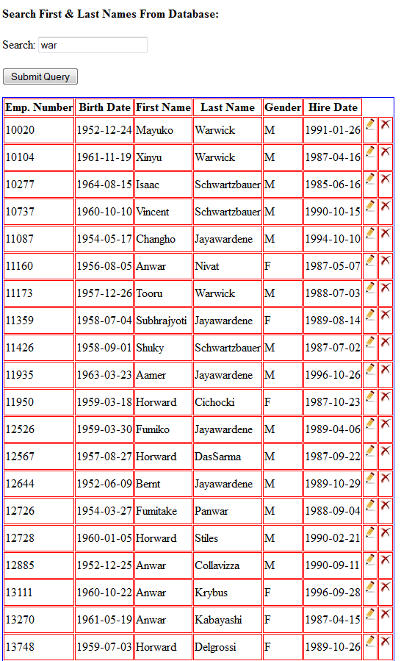

Figure 1 – Searching for Employees

1. **Adding Employee Records (3 pts.)**

New Employee records will be inserted. An HTML Form will allow the user to fill out all fields corresponding to all fields in the employees table. The HTML Form will be subjected to proper client-side validation prior to submission to PHP for database insertion (see REQ-006). A new employee ID will be generated for the new record (**Note: That this might be tricky given the current structure of the database**). The number of affected rows will be reported.

1. **Updating Employee Records (3 pts.)**

Employee records will be updated. A specified record will be selectable for update. **This will be done with an Edit button in the table that displays records (as shown in Figure 1 above).** An HTML Form will display, which will allow the user to modify fields that will be prepopulated to contain existing data corresponding to all fields in the employees table. The HTML Form will be subjected to proper client-side validation prior to submission to PHP for database update (see REQ-006). The number of affected rows will be reported.

1. **Employee Data Entry/Modifications Client-side Validation (3 pts.)**

The data on HTML forms for employee insertion or update in the database will be fully validated client-side before being allowed to submit to server-side code for database modification. The birth date and hire dates must be in YYYY-MM-DD number format. First and last names must begin with a capital letter followed by one or more lower case letters. The gender can be only “M” or “F”. Appropriate error messages must be displayed in areas next to the erroneous fields in the form and not as **pop-up boxes**.

1. **Deleting Employee Records (3 pts.)**

Employee records will be deleted. A specified record will be selectable for deletion. **This will be done with a Delete button in the table that displays records (as shown in Figure 1 above).** The deletion will be confirmed before executing. The number of affected rows will be reported.

1. **Limiting Access to Authorized Users (3 pts.)**

Only Authorized users will be able access the site’s pages and view/modify the data. A login screen that prompts for the username and password will be presented when a user tries to access any page of the website. The **password field will be masked with asterisks** when the user types. The login information will match against data stored in a new users table that you add to the Employees database and the password will be **appropriately hashed**. If the credentials match, they will be redirected to the site; otherwise they will stay on the login screen and get an appropriate message. Each page will have a Logout button, which will redirect to the login page and clear current logged in credentials when clicked.

1. **Including an Innovative Feature in the Web Site (6 pts.)**

A **significant and unique** feature will be added to the web site to give additional value to its role as an HR tool for interacting with Employee data. This feature will provide functionality in addition to the previous set of requirements.

# Development Process Requirements

1. **Using Source Control (5 pts.)**

The code for this project will be fully integrated with Source Control. The project will be added to a cloud-based Source Control repository from the beginning of development and the addition of every major feature (i.e. the completion of each general requirement) will be reflected in the code history. The project manager (email address: [michael.caines@nscc.ca](mailto:michael.caines@nscc.ca)) will be added as a read-only participant to the repository

# Instructions

1. Don’t forget that a code review is a **necessary** part of this assignment. You will need to show your code to the instructor in class on the due date while going through an evaluation of the site’s functionality. You will need to explain how the code works and complete the code review part of the rubric. You will need to do this to at least a developing level (see the Note in the rubric below).
2. *Late submissions will be subject to the late penalties laid out in the course outline.*

|  |  |  |  |  |
| --- | --- | --- | --- | --- |
| **INET 2005 – Assignment#1 Rubric** | | | | |
|  | **Insufficient** | **Developing** | **Competent** | **Professional** |
| **REQ001**  **Displaying Employee Records** | Insufficient (0 pts.)  No elements of this requirement are met. | Developing (1 pt.)  Only a few elements of this requirement are met. | Competent (2 pts.)  Most of the elements of this requirement are met. | Professional (3 pts.)  All elements of this requirement are met. |
| **REQ002**  **Paging through Employee Records** | Insufficient (0 pts.)  No elements of this requirement are met. | Developing (1 pt.)  Only a few elements of this requirement are met. | Competent (2 pts.)  Most of the elements of this requirement are met. | Professional (3 pts.)  All elements of this requirement are met. |
| **REQ003**  **Searching Employee Records** | Insufficient (0 pts.)  No elements of this requirement are met. | Developing (1 pt.)  Only a few elements of this requirement are met. | Competent (2 pts.)  Most of the elements of this requirement are met. | Professional (3 pts.)  All elements of this requirement are met. |
| **REQ004**  **Adding Employee Records** | Insufficient (0 pts.)  No elements of this requirement are met. | Developing (1 pt.)  Only a few elements of this requirement are met. | Competent (2 pts.)  Most of the elements of this requirement are met. | Professional (3 pts.)  All elements of this requirement are met. |
| **REQ005**  **Updating Employee Records** | Insufficient (0 pts.)  No elements of this requirement are met. | Developing (1 pt.)  Only a few elements of this requirement are met. | Competent (2 pts.)  Most of the elements of this requirement are met. | Professional (3 pts.)  All elements of this requirement are met. |
| **REQ006**  **Client-side Validation** | Insufficient (0 pts.)  No elements of this requirement are met. | Developing (1 pt.)  Only a few elements of this requirement are met. | Competent (2 pts.)  Most of the elements of this requirement are met. | Professional (3 pts.)  All elements of this requirement are met. |
| **REQ007**  **Deleting Employee Records** | Insufficient (0 pts.)  No elements of this requirement are met. | Developing (1 pt.)  Only a few elements of this requirement are met. | Competent (2 pts.)  Most of the elements of this requirement are met. | Professional (3 pts.)  All elements of this requirement are met. |
| **REQ008**  **Limiting Access to Site** | Insufficient (0 pts.)  No elements of this requirement are met. | Developing (1 pt.)  Only a few elements of this requirement are met. | Competent (2 pts.)  Most of the elements of this requirement are met. | Professional (3 pts.)  All elements of this requirement are met. |

|  |  |  |  |  |
| --- | --- | --- | --- | --- |
|  | **Insufficient** | **Developing** | **Competent** | **Professional** |
| **REQ009**  **Innovative Feature** | Insufficient (0 pts.)  No additional, unique feature is present other than functionality mentioned in REQ001 – REQ008. | Developing (2 pts.)  An additional, unique feature is present beyond the functionality mentioned in REQ001 – REQ008. However, it is both incomplete and the developer cannot make a case for how it adds significant value to the client. | Competent (4 pts.)  An additional, unique feature is present beyond the functionality mentioned in REQ001 – REQ008. However, it is either incomplete or the developer cannot make a case for how it adds significant value to the client. | Professional (6 pts.)  An additional, unique feature is present beyond the functionality mentioned in REQ001 – REQ008. The feature completely works and the developer can make a solid case for how it adds significant value to the client. |
| **REQ010**  **Source Control** | Insufficient (0 pts.)  No elements of this requirement are met. | Developing (1 pt.)  Only a few elements of this requirement are met. | Competent (3 pts.)  Most of the elements of this requirement are met. | Professional (5 pts.)  All elements of this requirement are met. |
| **Code Review** | Insufficient (0 pts.)  The developer is unable to explain the purpose of most of the code in the program or does not complete a code review.  **\*\* Note: You cannot receive a mark on the assignment without successfully completing a code review to at least a Developing level\*\*** | Developing (1 pt.)  The developer can explain the purpose of most of the code in the program. | Competent (3 pts.)  The developer can explain the purpose of **all** of the code in the program.  - AND SOME OF-  Code is well laid out and readable.  Variables and functions are named well.  Code is well commented.  PHP use is minimized for generating HTML. | Professional (5 pts.)  The developer can explain the purpose of **all** the code in the program.  - AND ALL OF-  Code is well laid out and readable.  Variables and functions are named well.  Code is well commented.  PHP use is minimized for generating HTML. |

|  |  |  |  |  |  |
| --- | --- | --- | --- | --- | --- |
| **Student Number:** | **Student Name:** |  | Total:  ( /40) |  | |
| **Comments:** | | | | |  |